|  |  |
| --- | --- |
| **Causes of the Spanish American War** Evidence.png  **Using Evidence** | |
| **Objective** | *Why did America invade Cuba and declare war on Spain?* |

|  |  |
| --- | --- |
| **Historical Context** | Since 1866, Cuba and Spain had been locked in a battle for Cuban independence. With Cuba only 90 miles from Florida’s coast, the United States was constantly monitoring the situation. Additionally, the Monroe Doctrine, issued in 1823, suggested that the United States would intervene in if they felt threatened. Finally, US business interests had flourished in Cuba between 1870 and 1898. Fueled by newspaper reporters and politicians, the intense debate of whether or not the United States should invade Cuba came to a pinnacle at the start of the Spanish American War. |

**Pre-Analysis:** Before analyzing the dawn of the Spanish American War, [first watch this video](https://drive.google.com/file/d/0B6SAc5Td_JPCMXNMNVRubmtLOGs/view?usp=sharing) to gather some pertinent background information. Prior to watching the video, read the questions below. While viewing the video, answer the questions below. 

|  |  |
| --- | --- |
| 1) How many miles from the United States is Cuba?   1. 90 2. 70 3. 50   2) Whose colony was Cuba?   1. Mexico 2. Spain 3. Brazil   3) What did Cuba export?   1. Sugar, Fruit, and Wheat 2. Sugar, Cotton, and Tea 3. Fruit, Sugar, and Tobacco   4) Were American businessmen investing money into Cuba?   1. Yes 2. No | 5) What was the name of the Navy ship that President McKinley moved into Havana?   1. USS Oklahoma 2. USS Montana 3. USS Maine   6) What happened to the US Navy ship that had been moved into Havana?   1. It was destroyed by a storm 2. Nothing happened to it 3. An explosion tore it apart & many died   7) When did the United States invade Cuba?   1. June 1898 2. December 1899 3. April 1898 |

**Document Analysis:**  Analyze the **four** documents below to determine why the United States invaded Cuba in 1898. Review each document carefully, and then answer the analysis questions that follow.

**Document 1:** President William McKinley's war message to Congress April 1898

The forcible intervention of the United States as a neutral to stop the ongoing war in Cuba between Cubans and the Spanish, according to the large dictates of humanity and following many historical precedents where neighboring states have interfered to check the hopeless sacrifices of life by internecine conflicts beyond their borders, is justifiable on rational grounds. It involves, however, hostile constraint upon both the parties to the contest as well to enforce a truce as to guide the eventual settlement.

The grounds for such intervention may be briefly summarized as follows:

First, in the cause of humanity and to put an end to the barbarities, bloodshed, starvation, and horrible miseries now existing there....*

Second, we owe it to our citizens in Cuba to afford them that protection and indemnity for life and property which no government there can or will afford ....

Third, the right to intervene may be justified by the very serious injury to the commerce, trade, and business of our people, and by the deliberate destruction of property and devastation of the island.

Fourth, and which is of the utmost importance.... With such a conflict waged for years in an island so near us and with which our people have such trade and business relations; when the lives and liberty of our citizens are in constant danger and their property destroyed and themselves ruined; where our trading vessels are liable to seizure and are seized at our very door by warships of a foreign nation, ... -- all these and others ... are a constant menace to our peace....

I have already transmitted to Congress the report... on the destruction of the battleship Maine... The destruction of that noble vessel has filled the national heart with inexpressible horror...The destruction of the Maine, by whatever exterior cause, is a patent and impressive proof of a state of things in Cuba that is intolerable....The Spanish government cannot assure safety and security to a vessel of the American Navy in the harbor of Havana on a mission of peace, and rightfully there....

*\* The first reason refers to the reconcentration camps that the Spanish set up for Cubans to protect them from warfare in the countryside between Cuban rebels fighting for independence and the Spanish army. The government of Spain claimed they could protect their Cuban citizens there safely, but newspaper reports revealed horrible conditions and violence against the Cubans, conducted by the Spanish.*

**Vocabulary:**

Humanity - humankind Commerce - economic activity, trade

Barbarities - extreme cruelty Liable - likely to be

**Document 1 - Analysis Questions:**

1. *Contextualization:* According to the US Constitution, which branch of government has to declare war?
   1. *Contextualization:* How might that have shaped President McKinley’s message, including the tone and the words he chose to use in this speech to Congress?
2. *Close Reading:* How does McKinley allude to the Monroe Doctrine to build support for the invasion of Cuba in the first paragraph?
3. *Close Reading:* McKinley lists four reasons as evidence that war with Spain/an invasion of Cuba was necessary. List the four reasons below in your own words.
   1. *Analysis:* Which reason is the most important, according to McKinley?
   2. *Contextualization:* Thinking about the contextualization and the war powers listed in the US Constitution, why do you think he suggests that this is the most important reason?
4. *Close Reading:* What kinds of words does President McKinley use to describe the explosion of the USS Maine?
   1. *Close Reading:* How does he use the incident with the USS Maine to try and build his argument for war with Spain?

**Document 2:** “Spanish Misrule” [Puck Magazine 1898](http://www.loc.gov/pictures/resource/ppmsca.28700/)  - the caption reads: “The duty of the hour: - to save her not only from Spain, but from a worse fate”



**Vocabulary:**

Anarchy - state of disorder

**Document 2 - Analysis Questions**:

1. *Close Reading:* According to this cartoon, what fire is spreading over the island of Cuba?
2. *Close Reading:* According to this cartoon, what are the two groups in Cuba who are creating/ fanning the flames of this fire?
   1. *Close Reading:* According to this cartoonist, which is a worse fate: Cubans fighting amongst themselves or the Cuban war against Spain for independence? Cite evidence from the cartoon to support your claim.
3. *Close Reading:* According to this cartoon, what is the duty of the hour for the United States?
   1. *Analysis:* Why do you think the cartoonist suggests it is a **duty** for the United States to invade Cuba and declare war on Spain?
4. *Analysis:* What do you think the cartoonist wanted viewers to walk away from the cartoon thinking about or feeling?

**Document 3:** Senator Redfield Proctor - speech in the US Senate (March 17, 1898)

**Historical Context:** Senator Proctor had just returned from Cuba. He was testifying as to what he saw when he delivered these remarks. Specifically, he was referring to the policy of Spanish Reconcentration. In 1896, General Weyler of Spain, in reaction to the continuing war between Spain and Cuba, implemented the first wave of the Spanish "Reconcentration Policy" that sent thousands of Cubans into concentration camps. Under Weyler's policy, the rural population had eight days to move into designated camps located in fortified towns; any person who failed to obey was shot. The housing in these areas was typically decaying, roofless, and virtually uninhabitable. Food was scarce and famine and disease quickly swept through the camps. By 1898, one third of Cuba's population had been forcibly sent into the concentration camps.

“...Torn from their homes, with foul earth, foul air, foul water and foul food, or none, what wonder that one-half have died and that one-quarter of the living are so diseased that they cannot be saved...

Little children are still walking about with arms and chests terribly emaciated, eyes swollen and abdomen bloated to three times the natural size. The physicians say these cases are hopeless. Deaths in the streets have not been uncommon….

I went to Cuba with a strong conviction that the picture had been overdrawn. I could not believe that out of a population of one million six hundred thousand, two hundred thousand had died within these Spanish forts…

My inquiries were entirely outside of sensational sources...What I saw I cannot tell so that others can see it. It must be seen with one's own eyes to be realized...To me the strongest appeal for declaring war on Spain is not ...the loss of the Maine...but the spectacle of a million and a half people, the entire native population of Cuba, struggling for freedom and rescue from the worst misgovernment of which I ever had knowledge…”

**Vocabulary:**

Emaciated - very thin, skeletal

Sensational - shocking, astonishing

**Document 3 - Analysis Questions**:

1. *Close Reading:* What are two things that the senator witnessed when visiting Cuban reconcentration camps?
2. *Close Reading:* Did the Senator arrive in Cuba believing that the truth was being reported or that facts about the situation were exaggerated? Cite textual evidence to support your claim.
3. *Analysis:* How could document 3 build or contribute to an argument that America should invade Cuba to protect the Cubans from the ill treatment they were receiving from the Spanish?
4. *Analysis:* How could document 3 be used in combination with the Monroe Doctrine (excerpted below) to justify an American invasion of Cuba and declaration of war against Spain?

“We owe it, therefore, to candor, and to the amicable relations existing between the United

States and those powers, to declare, that we should consider any attempt on their part to extend their system to any portion of this hemisphere, as dangerous to our peace and safety. With the existing colonies or dependencies of any European power we have not interfered, and shall not interfere. But with the governments who have declared their independence, and maintained it, and whose independence we have, on great consideration, and on just principles, acknowledged, we could not view any intervention for the purpose of oppressing them, or controlling, in any other manner, their destiny, by any European power in any other light than as the manifestation of an unfriendly disposition towards the United States....” - Monroe Doctrine (1823)

**Document 4a:** Graphs of Cuban Exports and Imports [(source of data)](https://evols.library.manoa.hawaii.edu/bitstream/handle/10524/369/JL33075.pdf?sequence=2)

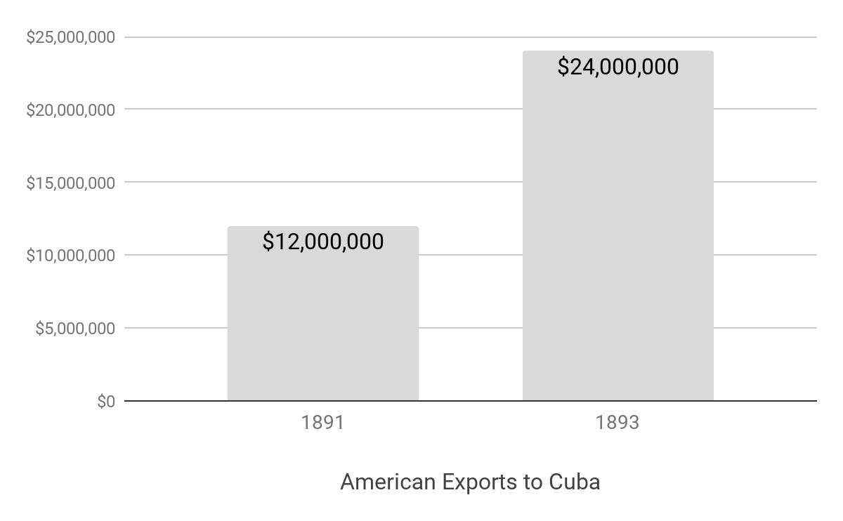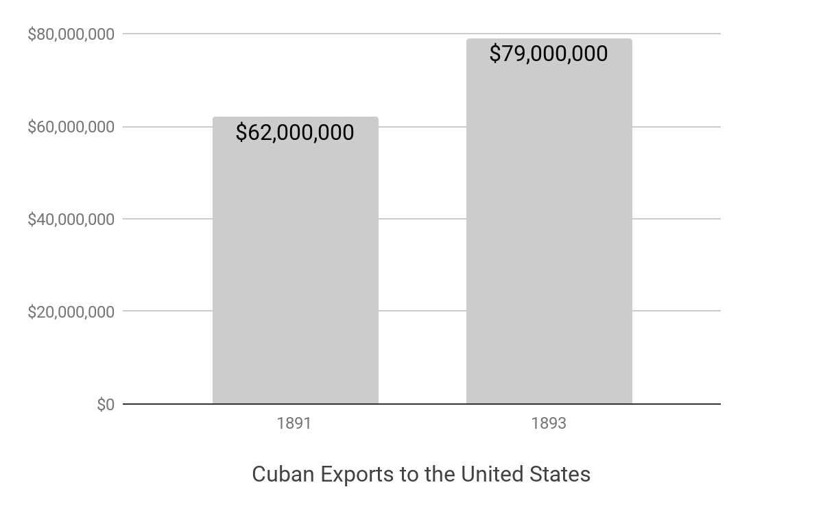

**Document 4b:** [**Cuba in 1898**](https://www.loc.gov/rr/hispanic/1898/hernandez.html) (Library of Congress)

Cuba's economy became even more closely linked with that of the United States than it had been earlier in the century. By the 1880s the US consumed most of Cuba’s exported sugar, tobacco, cacao, coffee, tropical fruits, and nuts; US exports in return were cereals, meats, manufactured goods, condensed milk, vegetable oils, cheese, and fuel Cuba also exported iron ore. The US imported all of Cuba’s copper production, about a quarter of US copper imports. Additionally, due to a sharp drop of sugar prices that took place from early 1884, the old Cuban "sugar nobility," unable to mechanize and cut costs, began to disintegrate and lose its dominant role in the island's economy and society. This facilitated U.S. penetration of the Cuban economy. Sugar estates and mining interests passed from Spanish and Cuban to U.S. hands, and it was U.S. capital, machinery and technicians that helped to save the sugar mills that remained competitive with European beet sugar. Furthermore, as the dependence of Cuban sugar on the U.S. market increased, the Cuban sugar producers were more and more at the mercy of the U.S. refiners to whom they sold their raw sugar. In 1894 nearly 90 percent of Cuba's exports went to the United States, which in turn provided Cuba with 38 percent of its imports. That same year Spain took only 6 percent of Cuba's exports, providing it with just 35 percent of its imports. Clearly, Spain had ceased to be Cuba's economic metropolis...it was now America.

**Document 4a & 4b - Analysis Questions:**

1. *Close Reading:* What do the graphs in document 4a suggest to you about the relationship between the Cuban economy and the US economy in the early 1890’s?
   1. *Close Reading:* How might this relationship have influenced the American decision to invade Cuba and declare war against Spain in 1898?
2. Close Reading: In document 4b, what evidence does the author provide to support the claim that: *“Cuba's economy became even more closely linked with that of the United States than it had been earlier in the century”*?
3. *Analysis:* What does: “Clearly, Spain had ceased to be Cuba's economic metropolis...it was now America...” suggest to you about how Americans might have viewed themselves in 1898 in relation to both Spain and Cuba?

|  |  |
| --- | --- |
| **Causes of the Spanish American War** Evidence.png  **Using Evidence** | |
| **Written Task** | *Why did America invade Cuba and declare war on Spain?* |

**Task -** Using the documents above, and your knowledge of US History, please complete the following:

|  |
| --- |
| Imagine it is March 1898 and you are living in the United States. You are a US Congressman from New York City. Soon, it will be time for Congress to vote on whether or not to declare war against Spain and invade Cuba. You have decided to vote yes and declare war against Spain. *Why are you deciding this? How will you explain your decision to your constituents?*  Write a short letter from your perspective as a member of US Congress, addressed to your constituents. **Argue in favor of war with Spain by describing one political, one social, and one economic reason** why you are voting yes to declare war on Spain and invade Cuba.   * Your letter should be at least three paragraphs long * Use must use evidence from **at least two of the documents above** to create your argument in favor of a declaration of war |

* **argue** means to “give reasons or cite evidence in support of an idea, action, or theory, typically with the aim of persuading others to share one's view.”